**Transfer Learning-Based Classification of Poultry Diseases for Enhanced Health Management**

**Team Name:**

“The Innovation Igniters”

**Team Members:**

1. Bhukya Vijaya Sri
2. Basthati Ramya Ramani
3. Banavathu Vasu
4. Batchu Rupa Sree

**Phase 1: Brainstorming & Ideation**

**Problem Statement:** Poultry farmers face difficulties in identifying diseases in chickens early, which can lead to large-scale infections and economic losses.

**Proposed Solution:** We propose an AI-based image classification system using Transfer Learning (ResNet50) to detect poultry diseases such as Coccidiosis, Salmonella, and Newcastle Disease from images.

**Target Users:** Poultry farmers, veterinarians, and agricultural researchers.

**Expected Outcome:** An easy-to-use web platform where users can upload a poultry image and receive instant disease classification feedback.

**Phase 2: Requirement Analysis**

**Technical Requirements:**

* Python, Flask
* TensorFlow / Keras
* HTML, CSS (for frontend)
* ResNet50 model
* VS Code is used for model training and also for creation of web interface

**Functional Requirements:**

* Upload image
* Predict disease using trained model
* Display result

**Constraints & Challenges:**

* Model accuracy depends on dataset quality.
* Limited labelled images for some rare diseases.

**Phase 3: Project Design**

**System Architecture Diagram:**

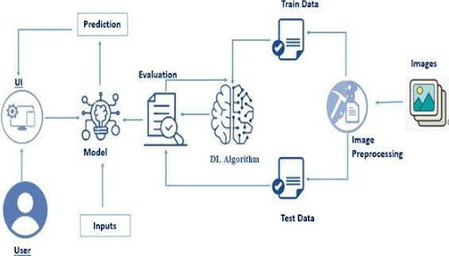

**User Flow:**

User opens site

⇩

Clicks on Get started Button

⇩

uploads poultry image

⇩

clicks submit

⇩

sees disease prediction

**UI/UX Considerations:**

* Simple upload form with image preview
* Predict button
* Result section with Disease Name

**Phase 4: Project Planning (Agile Methodologies)**

**Sprint Planning:**

* + Week 1: Dataset collection & preprocessing
  + Week 2: Model training and tuning
  + Week 3: Flask integration
  + Week 4: Frontend + Testing + Deployment

**Task Allocation:**

* + Member A: Model training
  + Member B: Flask backend
  + Member C: Frontend UI
  + Member D: Documentation & Testing

**Timeline & Milestones:**

* + Milestone 1: Dataset ready (Week 1)
  + Milestone 2: Model trained (Week 2)
  + Milestone 3: Web integration (Week 3)
  + Milestone 4: Testing + Report (Week 4)

**Phase 5: Project Development**

**Technology Stack Used:** Python, Flask, TensorFlow/Keras, ResNet50, HTML/CSS

**Development Process:**

* Trained ResNet50 on poultry dataset
* Created app.py with prediction route
* HTML templates for UI
* Uploaded image saved and pre-processed
* Model predicts and result shown on predict.html

**Challenges & Fixes:**

* ResNet50 needed image shape fixing → solved with image to array & resizing
* File not saving correctly → fixed with os. path. Join()
* Styling issues fixed via HTML template updates

**Phase 6: Functional & Performance Testing**

**Test Cases Executed:**

* Uploaded valid/invalid image formats
* Checked correct predictions for known test images
* UI responsiveness and error handling

**Bug Fixes & Improvements:**

* Fixed image upload not found bug
* Added image preview and file name display
* Improved styling for better UX

**Final Validation:**

* Project meets objectives of classifying poultry disease accurately
* Easy for non-technical users